 | Year 11 Earth and Environmental Science  Task 11: End of Unit test

Name: | Date | Score: /60

Question 1
Describe the difference between the terms referring to examples

a) Commensalism and Mutualism (4 marks)
1- commensalism one benefits other unharmed
1- commensalism example
1- mutualis where both organisms benefit from interaction
1- mutualism example
Parasitism and predation (4 marks)
1- parasitism where organism lives off living host which they harm
1- flea ect
1- predation is a feeding interaction of a predator and prey
1- predation example

Question 2
Below is a simplified diagram of the Carbon cycle
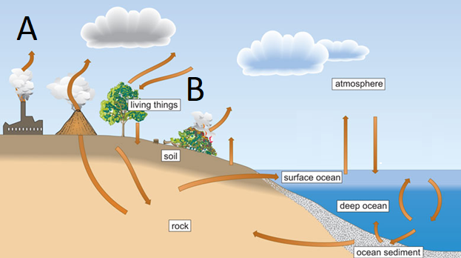

a) Name the processes shown by the letters A and B
A combustion
B photosynthesis

b) Humans have been impacting the carbon cycle for many years. Describe 2 ways in which humans have impacted the carbon cycle 2 marks
1- burning fossil fuels for energy
1- deforestation

c) Describe the impact in increasing carbon emissions has upon our planet. Refer to how this impacts biodiversity 3 marks
1- creates thicker layer of greenhouse gases
1- raises the global temperature
1- Many organisms have a specific temperature tolerance and will therefore be negatively impacted

d) Governments are now taking measures to reduce the impact of climate change. Discuss 3 ways we as humans can do to reduce our carbon emissions 3 marks
- Stop deforestation/ plant more trees
- Change our diet to reduce beef which is high for methane
- Renewable energy
- car use

Western Australia’s population is increasing rapidly and this has led scientists to say that the ‘rate at which water is being used in Perth is unsustainable’

a) Explain what this statement means for Perth’s water supply 2 marks
- water is being extracted faster than be replaced naturally
- water supply will become reduced for Perth

b) Name three strategies that the government of Western Australia has taken to ensure there is enough water supply for the population 3 marks
Groundwater extraction
Desalination
Groundwater replenishment

Strict government controls require wastewater to be treated to a level that will minimise the impact on the environment.

a) What are the three stages of wastewater treatment? (3 marks)
primary secondary and tertiary

c) Name the 3 steps involved in the final stage of wastewater treatment to ensure that treated water water for Groundwater replenishment meets drinking standards 3 marks
ultrafiltration, reverse osmosis and uv light

Salinity/ Eutrophication

For many decades, farmers in WA were encouraged by the government to clear native vegetation from their land and to plant crops and pasture. More recently, it has been recognized that this policy of land clearing has had disastrous effects on the environment.
a) Describe two ways in which the long term clearing of land for agriculture has affected water resources in Western Australia? 2 marks
water table has risen
brought salt to surface

b) What is the name for the process you described above? 1 mark
salinity
c) Describe how the clearing of land for agriculture has affected biodiversity in Western Australia? 3 marks
1- clearing destroys habitat
Reduction food supply
Reduced native vegetation
Diversity of species reduced
d) Farmers discovered that their crops grew better if they applied nitrogen-rich fertilisers to the soil. Describe the effects that this practice could have on the health of nearby waterways 3 marks
fertilisers washed into waterways
causing algal blooms
cause fish kills

e) Describe the measures that farmers can do to lessen these effects 2 marks
- Use less fertilizer
- reduce fertilizer use when it is raining

f) What are some measures the local government could do to reduce the prevalence of algal blooms in local waterways 2 marks
- planting more vegetation along waterway
- oxygenation tanks to increase water moving

